**Difference between Document and Window Object**

***Introduction***

Every browser operation is a combined process of two different models; The Browser Object Model (BOM), and Document Object Model (DOM). Window object and Document object often look alike and confusing? You can access a document object either using *window.document* property or using document object directly as window is a global object.

***Window Vs Document***

***Window Object***

The topmost object in the BOM is the window object representing the window or tab sometimes. *Window object* has properties like browser history, location and the device’s screen etc.

In the case of a multi tab browser, a window object represents a single tab, but some of its properties like innerHeight, innerWidth and methods like resizeTo() will affect the whole browser window.

***Document***

When a web page is loaded, the browser creates a *Document Object* Model of the page. The document object represents the whole html document as a tree of Objects(HTML, HEAD, BODY, and other HTML tags). It is the root element that represents the html document.

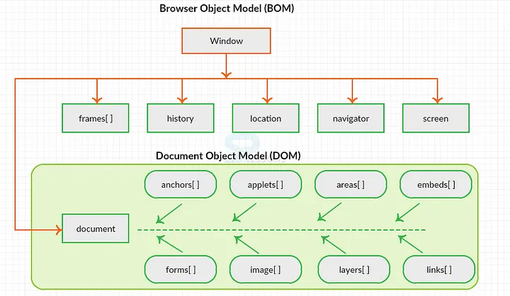

***Conclusion***

The other major difference is that both window object and document object have properties and methods. Few method names are the same in both objects but with different behaviour.